Software Requirements Specification

for

Sunland Wind & Solar

Version 1.4

Prepared by Monde Murphy, Bryan Bolin, Brandon Nelson, Stephen Richardson of Shuriken Development

DATE: April 24, 2018

Table of Contents

1. Customer Statement of Requirements 1

1.1 The Problem 1

1.2 How Things are Currently Done 1

1.3 The Requested Solution 1

1.4 Feasibility Analysis 2

1.5 System Requirements 2

2. Glossary of Terms 4

3. Function Requirements Specification 4

3.1 Stakeholders 4

3.2 Actors and Goals 4

3.3 Use Cases 6

3.3.1 Overview Class Diagram 6

3.3.2 Schedule Install Time Diagram 7

3.3.3 Check Balance Activity Diagram 9

3.3.4 Get Lead Information Activity Diagram 10

3.3.5 Schedule Install Time Activity Diagram 11

3.4 Analysis Class Diagrams 13

3.4.1 General Analysis Class Diagram 13

3.4.2 Agent Analysis Class Diagram 13

3.4.3 Pins Analysis Class Diagram 14

3.4.4 Installer Analysis Class Diagram 14

3.4.5 Office Staff Analysis Class Diagram 15

3.4.6 Billing Analysis Class Diagram 15

3.4.7 Manager Analysis Class Diagram 16

3.5 Interaction Diagrams 16

3.5.1 Check Balance Communication Diagram 16

3.5.2 Check Balance Sequence Diagram 17

3.5.3 Get lead Information Communication Diagram 18

3.5.4 Get Lead Information Sequence Diagram 19

3.5.5 Schedule Install Time Communication Diagram 20

3.5.6 Schedule Install Time Sequence Diagram 21

4. Non-Functional Requirements 23

5. References 23

6. User Interface 23

6.1 Website User Interface 24

6.2 Mobile Application User Interface 29

7. Effort Breakdown Table 37

8. Appendix 38

Revision History

|  |  |  |  |
| --- | --- | --- | --- |
| **Name** | **Date** | **Reason For Changes** | **Version** |
| Monde Murphy | 4/02 | Initial Creation and Rough Draft | 1.0 |
| Monde Murphy | 4/13 | Added User Interface and made minor changes | 1.1 |
| Stephen Richardson | 4/22 | Added Customer Requirements and references | 1.2 |
| Monde Murphy | 4/23 | Added more diagrams and descriptions | 1.3 |
| Stephen Richardson | 4/24 | Added Analysis Class Diagrams | 1.4 |

# Customer Statement of Requirements

Sunland Wind and Solar has requested a new system for finding and leads and tracking all information concerning leads and customers. They want something that they know is always up-to-date and will allow them to separate who gets to see what, i.e. individual employees see only information relevant to them while managers are privy to more sensitive data. The system needs to be mobile as well as desktop-enabled and should run reports.

## The Problem

Sunland Wind and Solar is a company that installs and maintains alternative wind and solar energy system for residential and commercial customers. A majority of their business is drummed up by field agents going door-to-door, finding potential leads and gathering estimates. Sunland Wind and Solar needs a way to divvy up the work among the field agents and help the field agents keep track of customers and leads. Customer information, such as personal, billing, estimates, installation, and other notes need to be stored and installation and check-up appointments need to be scheduled and kept. Reports need to be run as well as employee work hours and performance.

## How Things are Currently Done

Currently, field agents are assigned a particular area of land, given a map of that area, given a bundle of empty forms and sent to work. The field agent uses the map and any notes on it to try and find possible leads. Any leads found, estimates performed, appointments scheduled or questions are communicated to the home office via cell phone call. This method has a huge margin of error. Field agents may get lost or wander into another agent’s designated area. Agents might unintentionally revisit buildings. Appointments made are sometimes miscommunicated and/or forgotten, upsetting the customer. Running reports consists of digging through spreadsheets to find the desired information, and the work hours and performance of field agents in particular are almost completely recorded by the honor system (i.e. we’ll just trust that you’re not lying). In short, the current methods for information storage and communication are unreliable, and the new system addresses these issues.

## The Requested Solution

Sunland Wind and Solar has requested an application and a website that will work in tandem to help track customers, leads, agent movements, etc. The app would run on field agents’ mobile devices. The agent will sign in, and the app will track the agent’s location and the length of time for which they are logged in. The app will open to a google map with a view limited to the agent’s assigned area. Field agent’s will be able to place several types of pins on the map. The pins will have labels such as ‘Not Interested/Do Not Disturb’, ‘Not Interested At This Time’, ‘Lead’, ‘Customer’, and ‘Miscellaneous’. Tapping on a placed pin will allow the agent to pull up forms, make notes and add information relevant to the type of pin it is. For example, tapping on a ‘lead’ pin will pull up the potential customer’s name, address, contact information and any notes the agent may have. Tapping on a ‘customer’ pin would pull up an estimate form, or a completed estimate, pictures of the building, installation schedule, etc.

The accompanying website would provide all the functionality of the app and more. Clerical staff will be able to run reports, look up and edit customer information, and track agent movements and times. With manager permissions, office employees will be able to evaluate and approve credit, process billing and rebates, and calculate employee pay and commission. Managers will be able to edit the field agent’s working area, employee profiles and performance, customer billing, paychecks and commissions, and grant system permissions.

## Feasibility Analysis

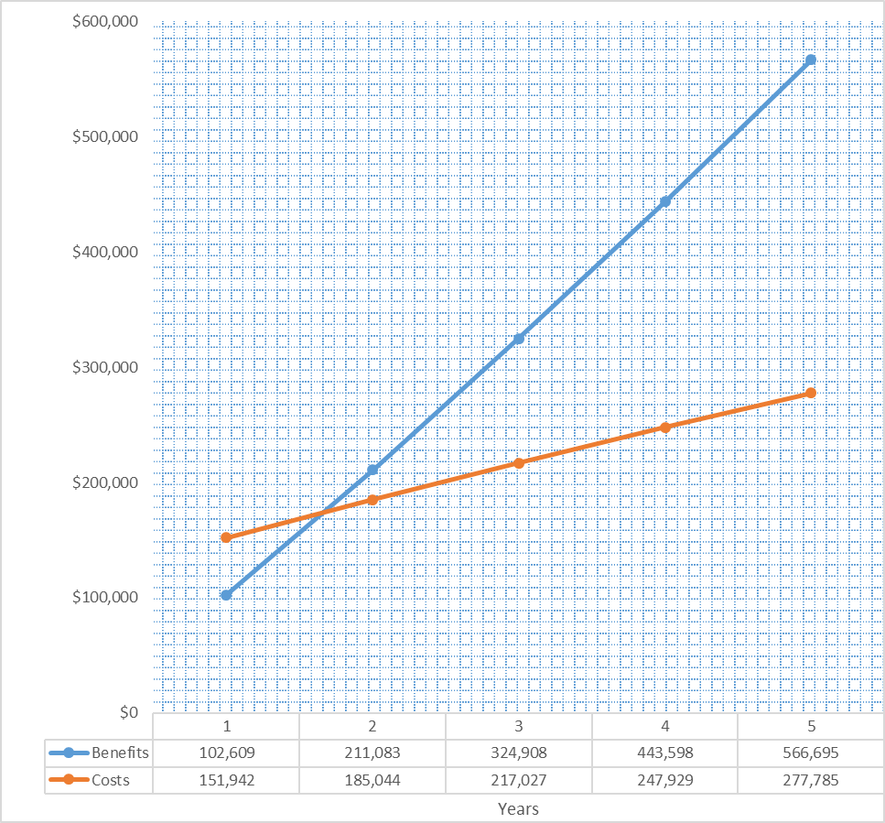The feasibility of implementing the requested system is split into three parts: technical feasibility, economic feasibility, and organizational feasibility. First to consider is technical feasibility, assessing the developer’s ability to create the system. The system will require a modified version of google maps to track customers and leads. This has been done before and the developers in question have access to someone with experience in this area. The rest of the system is a rather typical information management and retrieval system, and the developers are completely capable of providing the system. Nothing in the system will be technically difficult or terribly unfamiliar to the employees at Sunland, so training in using the system shouldn’t take more than a day. The system will need to be compatible with google maps, google calendars, and Microsoft Access, as well as be able to access data from Zillow. It also needs to be able to run on Android and IOS devices, all of which is doable. This project is technically feasible.

Secondly, can this project turn a profit? The initial cost of the system is estimated to be $157,260, with a continuing cost of $36,660 per year for a cloud subscription (“EC2 Instance Pricing – Amazon Web Services (AWS)”) and an additional $4,800 in projected maintenance to keep things running smoothly. However, the estimated revenue from increased sales in addition to the $31,200 saved yearly because of employee retention (Merhar, “Employee Retention - The Real Cost of Losing an Employee”) will outweigh the cost of the system within the first year, as shown in the graph to the right. This system, is economically feasible.

Finally, the Organizational Feasibility needs to be considered. How well will this system line up with Sunland’s needs and goals and will it be used? This system has been contracted by Sunland Wind and Solar’s owner, so it is evident that there is real desire for this system. The system is being designed to help Sunland track customers more easily and help the staff do their jobs more quickly and more simply. The system is being built around Sunland’s specific needs in order to help their business run more efficiently and successfully. Finally, the system is will be built with the end users in mind. It will be easy to learn, simple to use, and make the jobs of the staff at Sunland Wind and Solar easier. This system is organizationally feasible.

## System Requirements

Following are two bulleted lists outlining what the app and the website need to be able to do respectively.

**The app must:**

* Have employees sign in using a company associated username and password
* Allow employees to clock in, clock out, clock lunchtimes and manage time off.
* Track employee movements via GPS while the employee is clocked in.
* Have an emergency button to contact the office in case of emergencies.
* Show a limited view of Google maps pertaining to their route.
* Allow the placement of pins on the google maps to corresponding buildings.
* Have pins of 3 different designations: Customer, Lead/Interested, Uninterested/Do Not Disturb.
* Remove Uninterested pins after the space of 2 years, or a change of ownership, as noted by Zillow and other realty sales sights.
* Alert the field agent of the deletion of uninterested pins.
* Allow the field agent to make notes on and add pictures to any pin.
* Show a picture of the property on any pin.
* Allow for the deletion of pins.
* On a lead pin, allow the field agent to record the lead’s information (name, phone number, etc), as well schedule a meeting for an estimate.
* Provide access to the estimate form and allow the field agent to fill it out on the app.
* Allow the field agent to change the lead pin directly to a customer pin, transferring all information to the pin automatically.
* Allow the field agent to collect any billing information.
* Automatically notify the office of the new customer within 5 minutes of being created so that the credit approval and billing process may begin.
* Allow the field agent to schedule installation using a google calendar synced with the calendar that the installers use.
* Automatically notify the installers of a new appointment within 5 minutes of creation.
* Backup data to the company’s databanks stored in the cloud and Microsoft Access.
* Sync data with the database every 10 minutes.
* Be compatible with Android, iOS, Microsoft and Google mobile devices.

**The website must:**

* Provide all the functionality of the app.
* Allow employees to view salary, commission, and other personal information.
* Provide various levels of security clearance.
* Allow office staff to process financing, billing, payments and rebates.
* Allow office staff to view customer information and make any necessary changes.
* Allow office staff with any applicable security clearances to run reports.
* Allow office staff to create and save custom reports.
* Allow managers to override and manage billing.
* Allow managers to create, delete and edit employee profiles.
* Allow managers to manage employee commissions, pay and salaries.
* Allow managers to grant and revoke security clearances.
* Be accessible from any computer with a common browser.

# Glossary of Terms

**Attribute** – a quality something has. In computer science, is often a value, such as a number, words or a designation of true or false.

**Cloud** – computing power owned by a large corporation, such as Amazon, where data can be processed and stored for a fee

**Leads** - potential customers who have been contacted by a field agent

**Method**- in computer science, the manipulation of data to accomplish a goal. i.e. total the numbers or calculate the odds of ## team winning the Superbowl.

**Object**- a term used in computer science for a set of data(attributes) and data manipulation algorithms(methods) that relate to each other. Example: a dog object has the attributes of furry, brown and playful, and the methods fetch, run, and chase the squirrel.

**Pins** – geographic coordinates stored with accompanying information such as customer notes, installation date, etc.

**UI** – User Interface

# Function Requirements Specification

## Stakeholders

-Office Personnel

-Owner

-Manager

-Commercial Agent

-Residential Agent

-Install Team

## Actors and Goals

All Users

* Add notes to pin
* Add tasks to pin
* Sign-in with personal device
* Account works as time card

Commercial Agents

* Create pins to mark leads for possible customers.
* Add estate information to pin
* Add customer information to pin
* Scheduling installations
* Add ‘no approach’ marker
* Add ‘in process’ marker
* Add ‘declined services’ marker

Residential Agents

* Create pins to mark leads for possible customers.
* Add estate information to pin
* Add customer information to pin
* Scheduling installations
* Add ‘no approach’ marker
* Add ‘in process’ marker
* Add ‘declined services’ marker

Office Personnel

* Calculate estimates for leads
* Scheduling sales appointments
* Create Check-up
* Reschedule Check-up

## Use Cases

### Overview Class Diagram

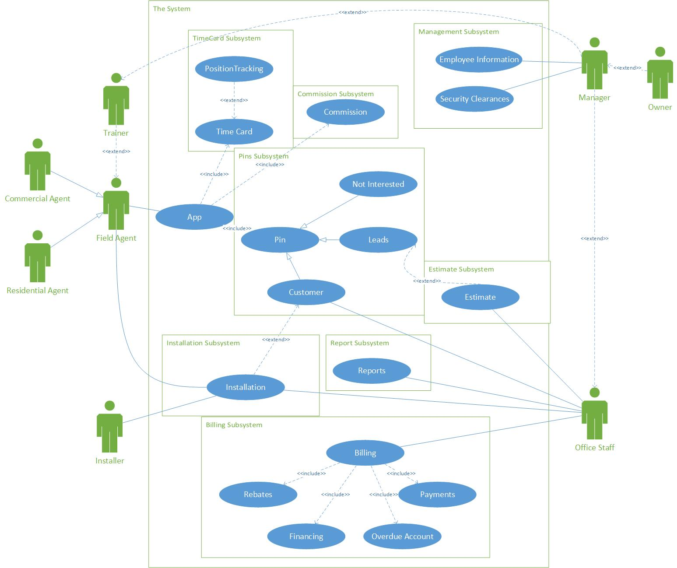This diagram shows how the system interacts with each of its many features.

### Schedule Install Time Diagram

This diagram shows how the system will interact with each user when scheduling an install time.

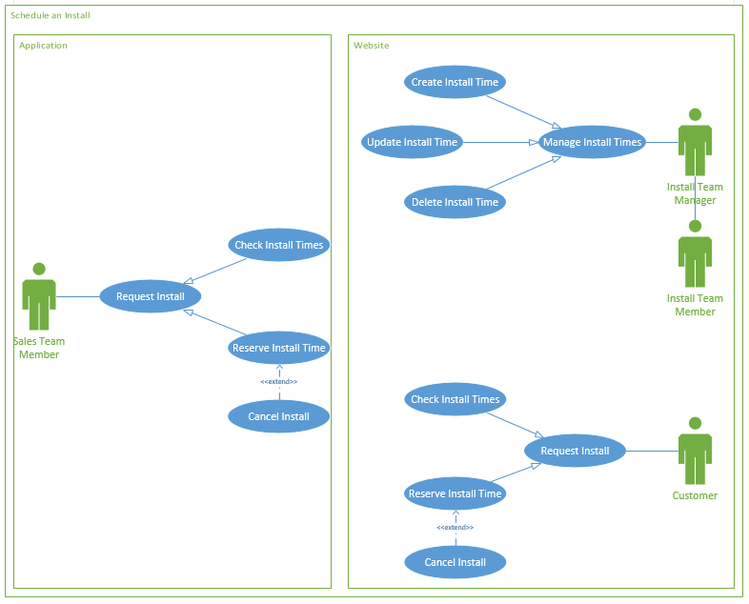

|  |  |  |
| --- | --- | --- |
| Use case name: Manage Install Time | ID: 72 | Importance Level: High |
| Primary actor: Field Agent | Use case type: Detailed, Essential | |
| Stakeholders and interests:  Field Agent – wants to schedule an install quickly with little effort from the customer  Installer – wants to have accurate information on calendar for install times, also needs to be able to update and change any installs that they are in charge of  Office Personnel – wants to keep the installers schedules spread out between all the different installers, needs to be able to update any install appointments information  Customer – wants an install to be as smooth as possible and be updated on any changes | | |
| Brief description:  This use case is used to manage any installs that will be scheduled by primarily field agents. | | |
| Trigger:  The field agent, installer, or office personnel use the system to update or schedule an install for a customer. | | |
| Relationships:  Association: Field Agent, Installer, Office Personnel  Include: Create Install Time, Update Install Time, Check Availability | | |
| Normal flow of events:   1. An employee opens the app to the installation page. 2. If the field agent needs to make a new install, the Create Install Time use case is activated. 3. If the field agent needs to update an install time, the Update Install Time use case is activated. | | |

### Check Balance Activity Diagram

This diagram shows the different choices available when checking your balance.

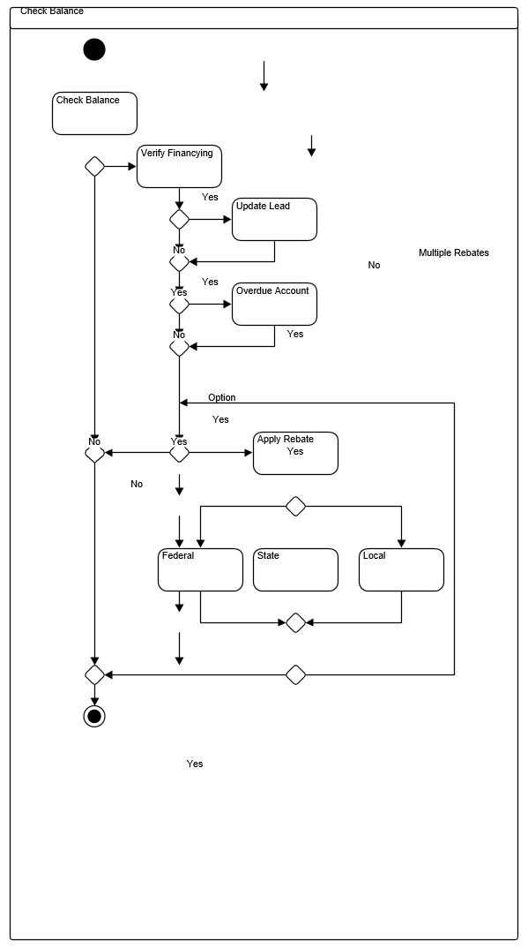

### Get Lead Information Activity Diagram

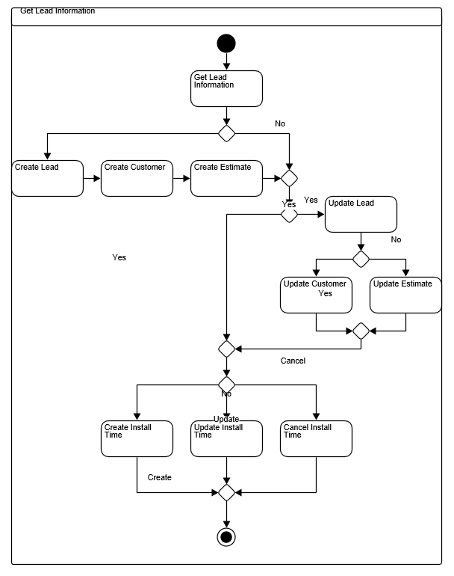This diagram shows the different options available when getting lead information.

### Schedule Install Time Activity Diagram

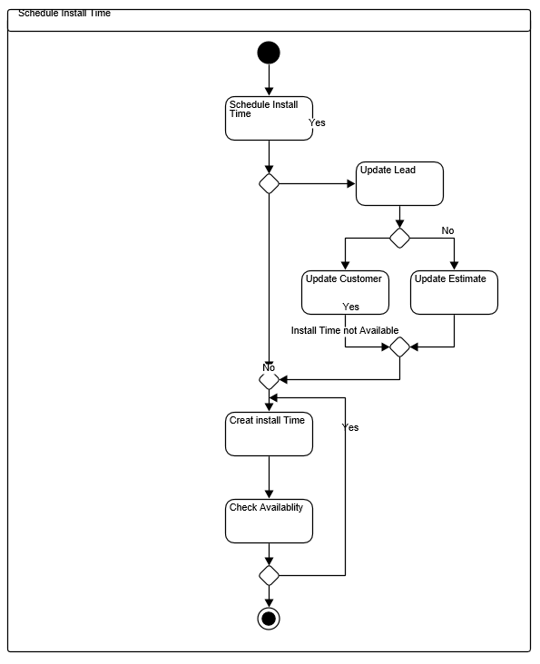This diagram shows you the available options when scheduling an installation time.

## Analysis Class Diagrams

### General Analysis Class Diagram

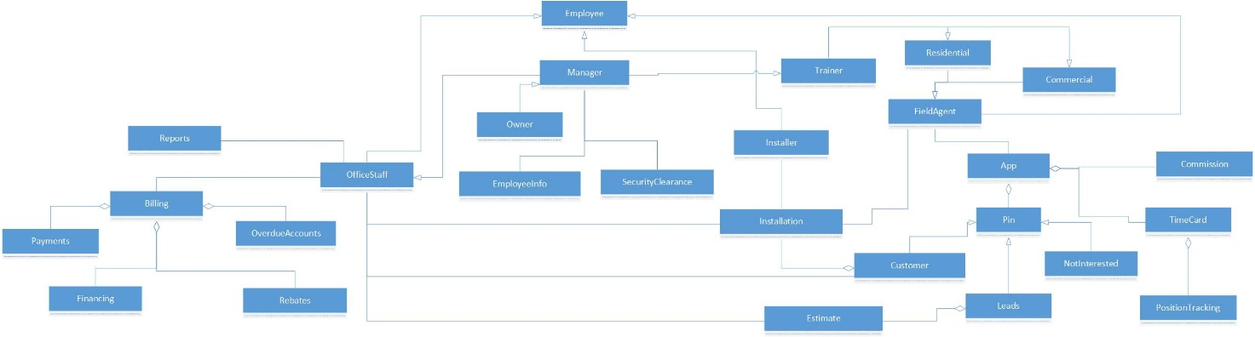This is a diagram that shows how all the different objects within the system interact with each other. An arrow means that the object at the tail end has the same attributes and methods as the object at the arrow end in addition to what is listed. A diamond means that the objects at the tail end are closely related to the objects at the diamond end.

### Agent Analysis Class Diagram

This diagram shows the objects available for the field agent to interact with and their attributes and methods. Attribute and method names have been shortened, and the arrows work the same as in the general overview diagram. Attributes are above the dividing line and methods are below.

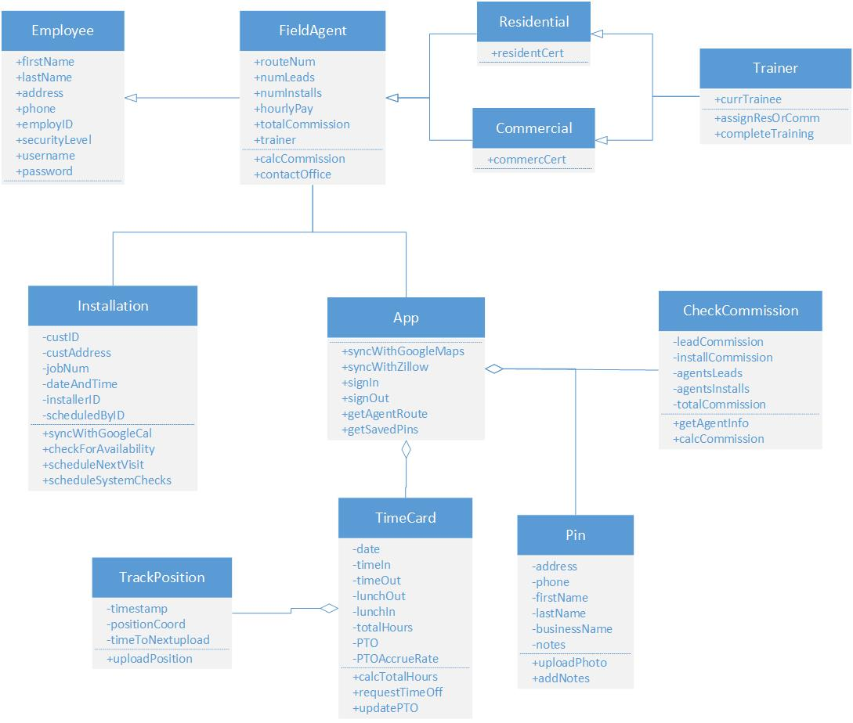

### Pins Analysis Class Diagram

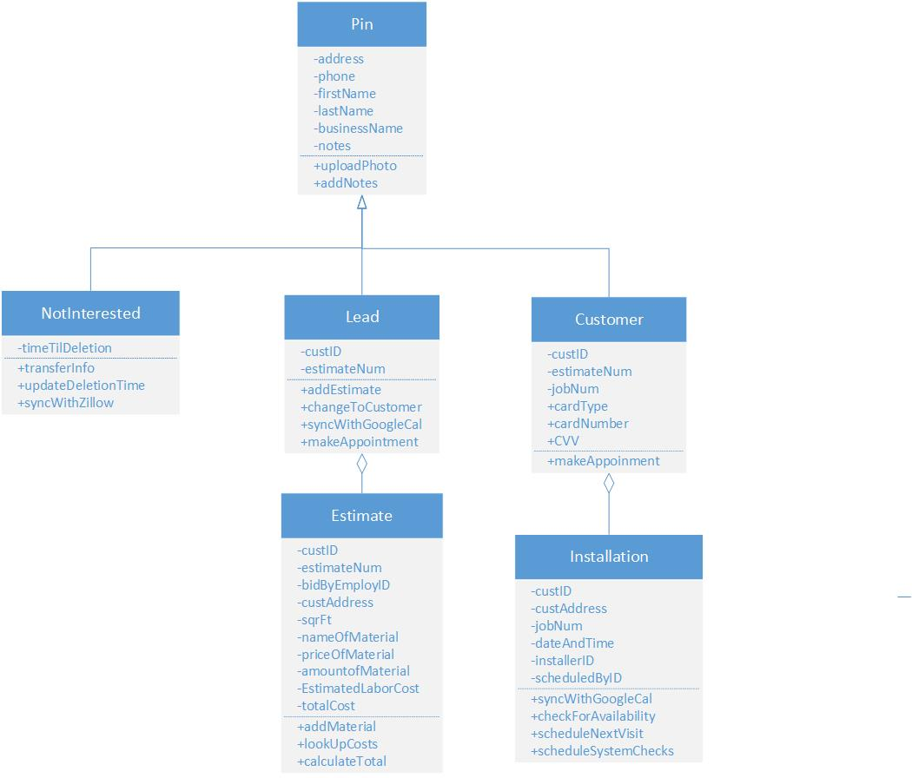This diagram shows the general pin object, with its three types, how they interact with the estimate and installation objects, and the attributes and methods for all of them. The pins will be placed on the google map using the app.

### Installer Analysis Class Diagram

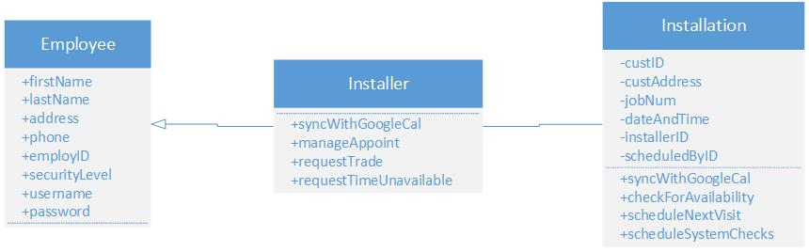This diagram shows the objects the Installer interacts with and the associated attributes and methods. These objects particularly pertain to scheduling using the app and Google Calendars.

### Office Staff Analysis Class Diagram

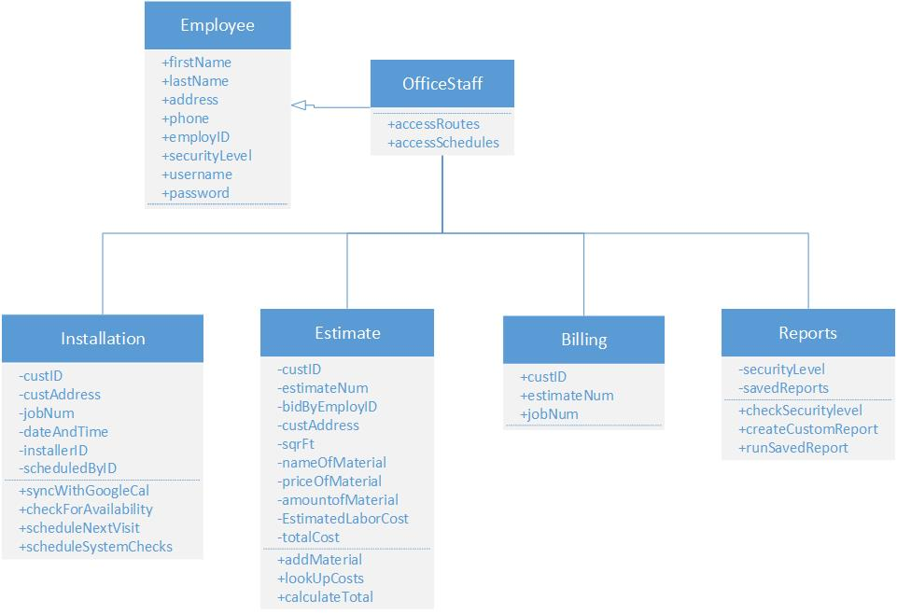This diagram shows all the objects the office staff object directly interacts with and their accompanying attributes and methods.

### Billing Analysis Class Diagram

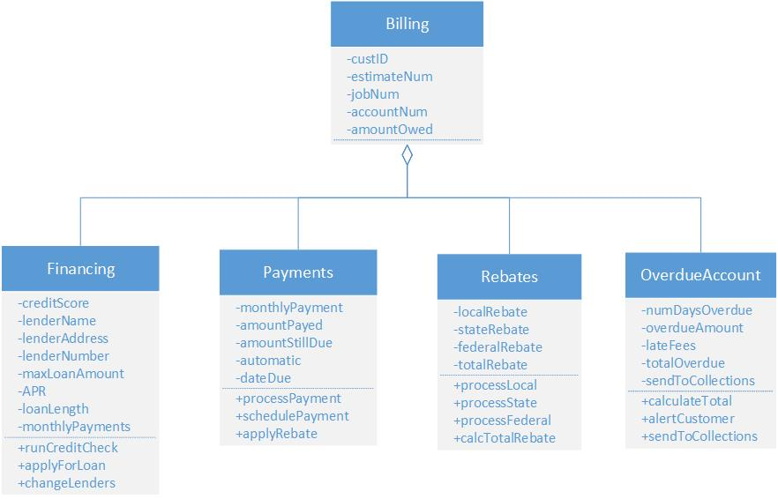This diagram shows all the objects associated with billing, how the relate to each other and their attributes and methods.

### Manager Analysis Class Diagram

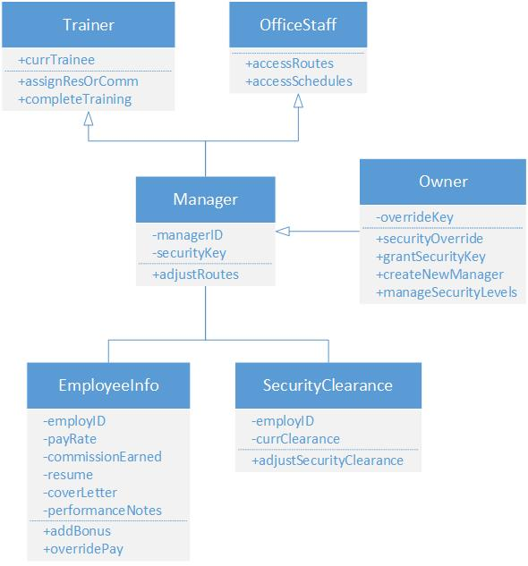This diagram shows that managers inherit all the attributes and methods available to trainers and office staff, as well as a couple more objects and their associated attributes and methods.

## Interaction Diagrams

### Check Balance Communication Diagram

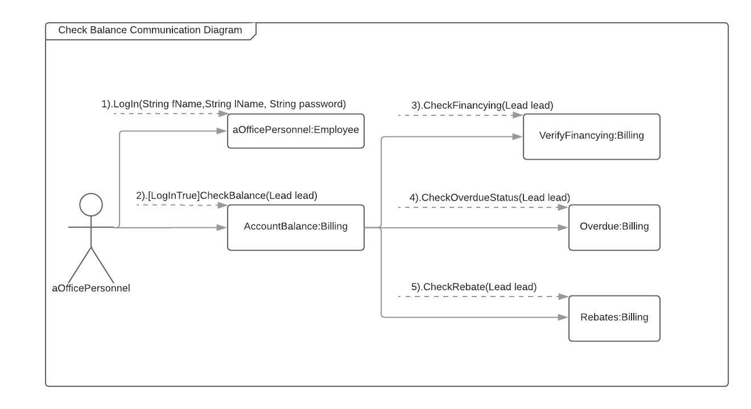This diagram shows how the system will communicate with the user when checking your balance.

### Check Balance Sequence Diagram

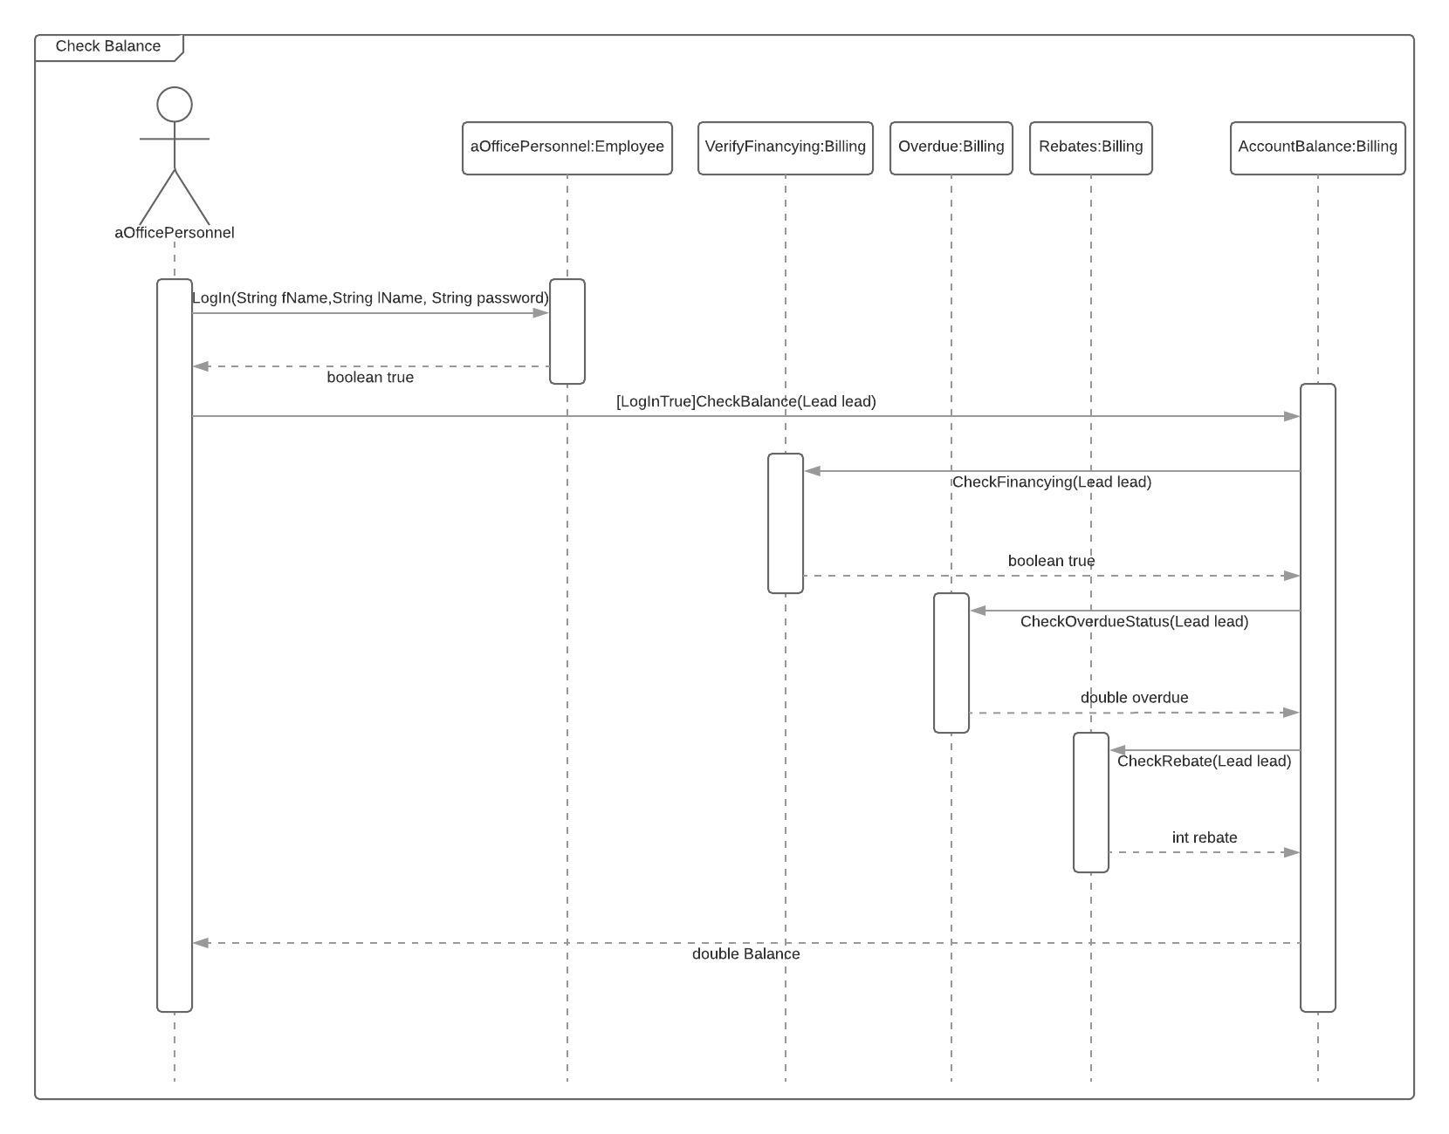This diagram shows the process the system will take to check a balance within the system.

### Get lead Information Communication Diagram

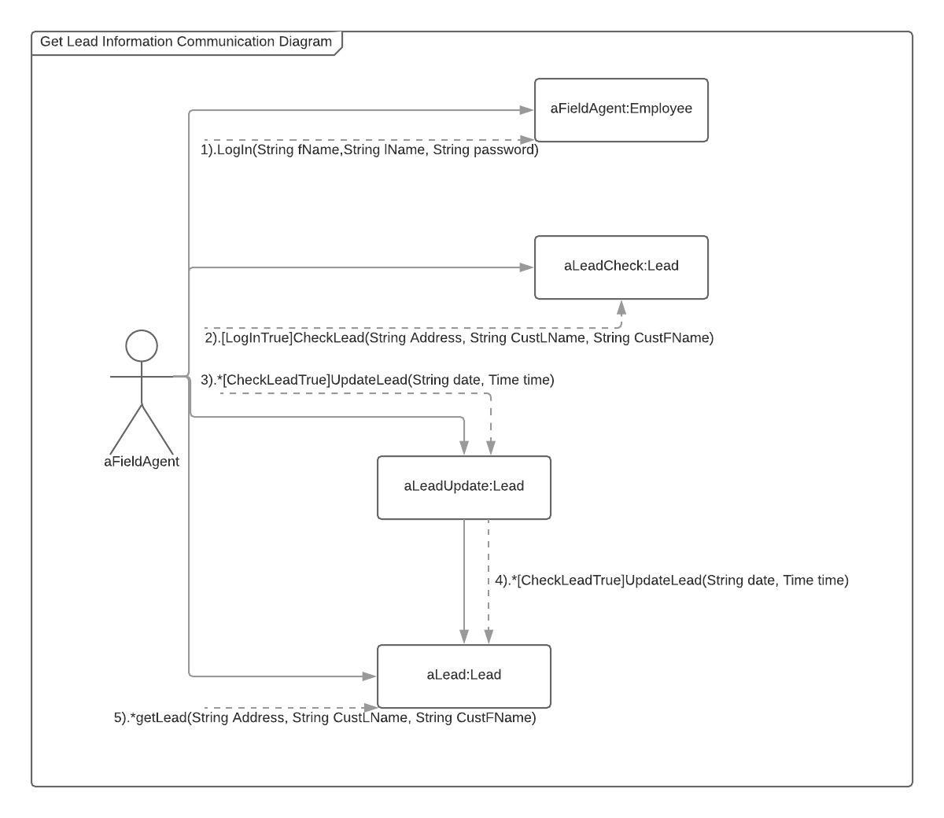This diagram shows how a field agent interacts with the system to obtain lead information.

### Get Lead Information Sequence Diagram

This diagram shows the steps the system will take to obtain lead information. 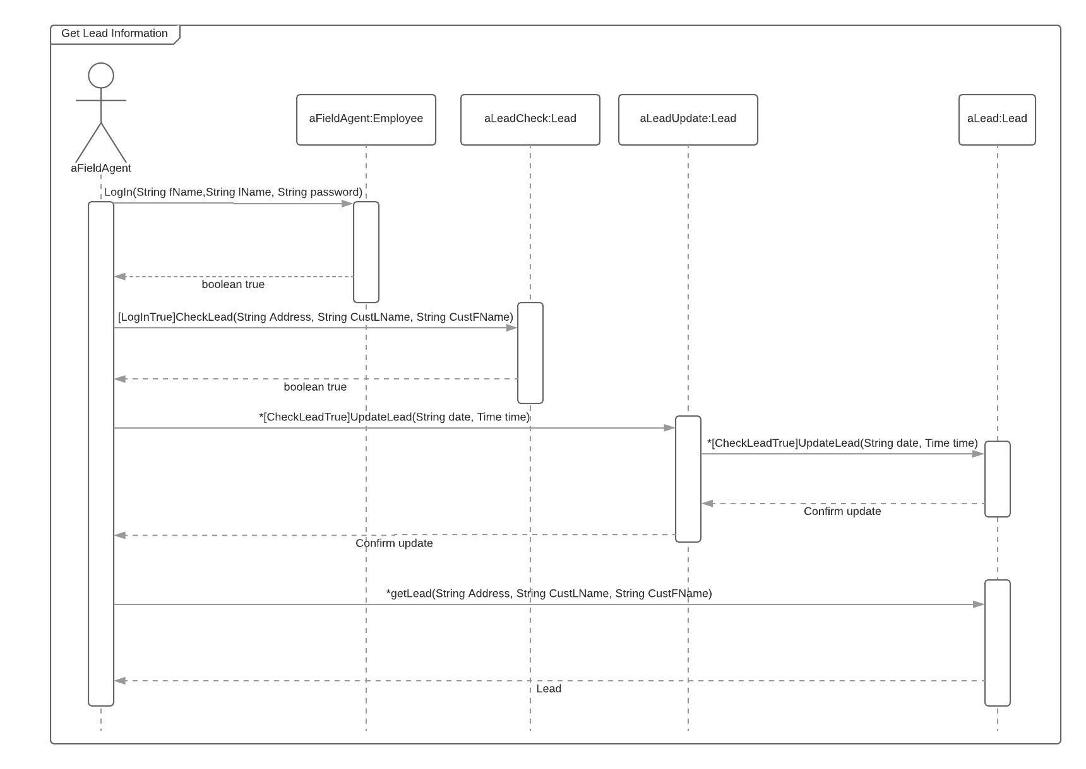

### Schedule Install Time Communication Diagram

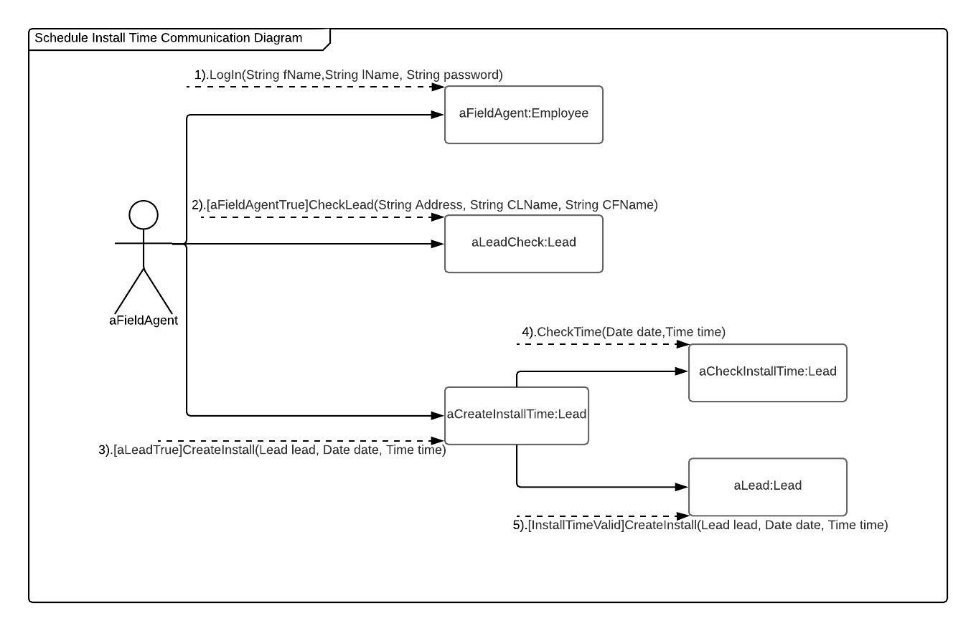This diagram shows how a field agent interacts with the system to schedule an install time.

### Schedule Install Time Sequence Diagram

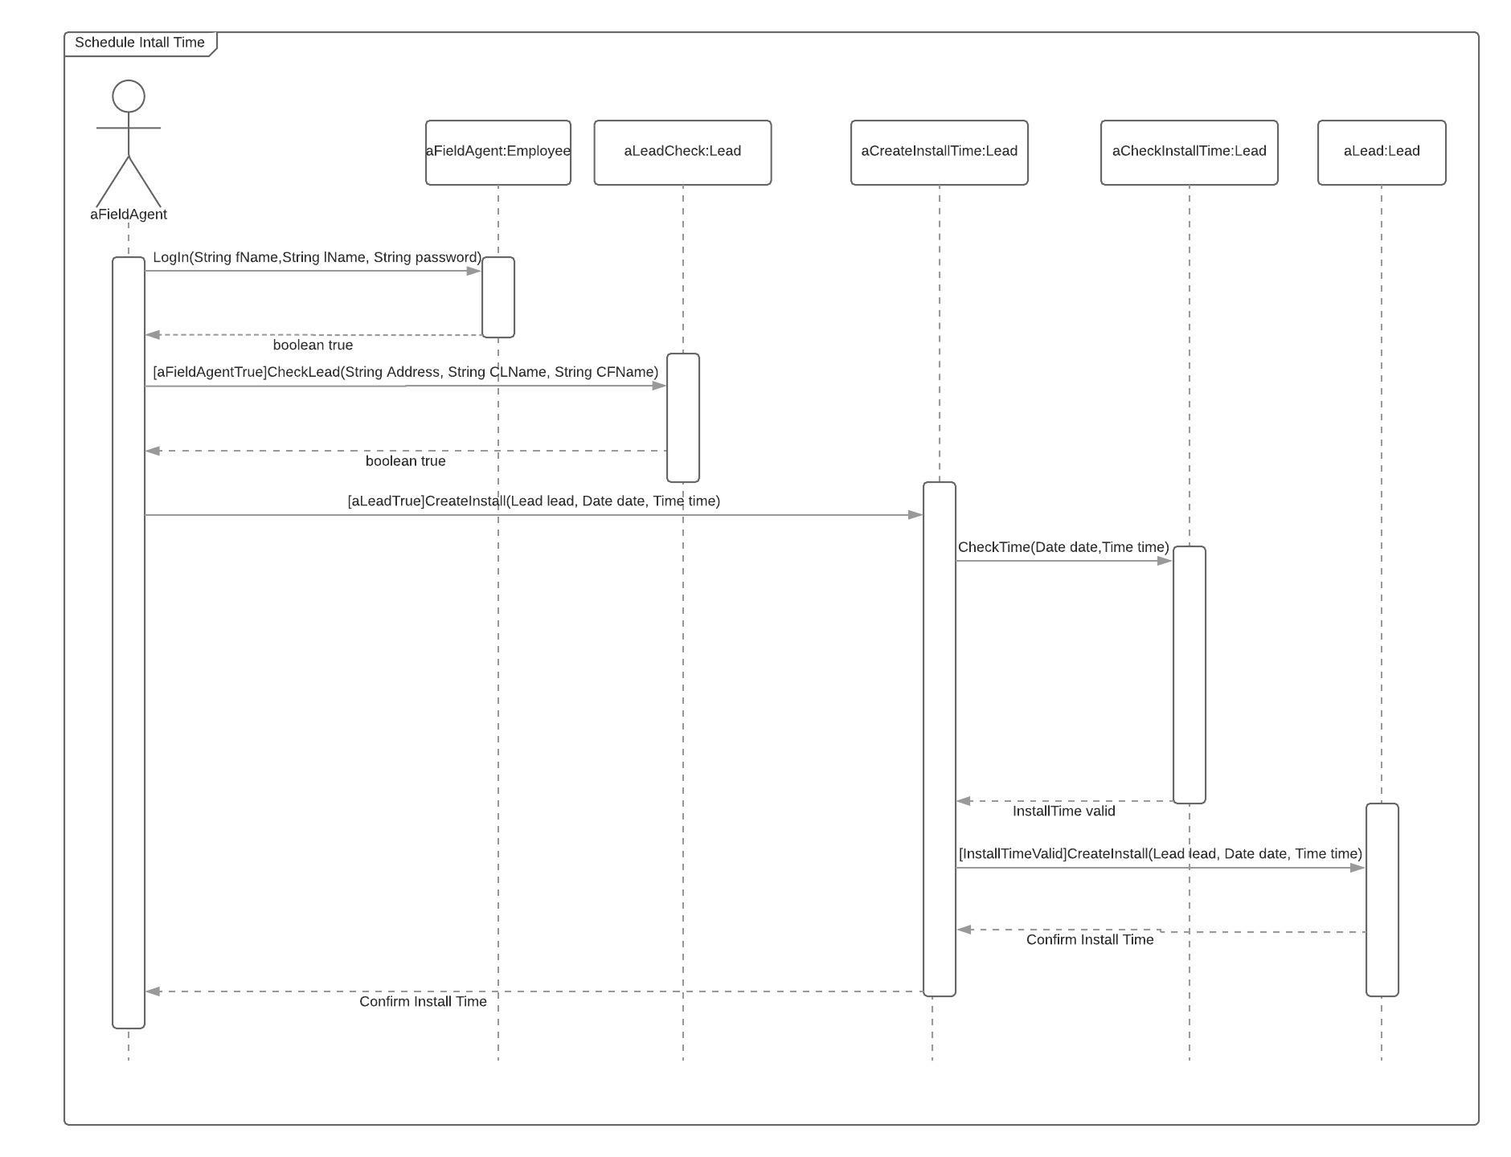This diagram shows the steps the system will take to schedule an installation time.

# Non-Functional Requirements

**Operational**

* The system will have data back up so that the possibility of data loss is minimal.
* All information will be stored in the cloud, and information will be retained for a minimum of 5 years.

**Performance**

* The cloud processing will be sufficient to handle multiple employee requests at the same time without being bottlenecked.
* The cloud servers will have sufficient capacity/flexibility to store data on all potential customers and employee information.

**Security**

* All customer or employee information being passed to the cloud will be through a secure and encrypted connection.
* The application will require user access credentials to access and store all information in an encrypted state to ensure data security.
* User credentials will be frequently updated.

**Cultural/Political**

* The system will not store any customer information without their explicit consent.
* Customer information will not be shared with any entity outside of Sunderland Wind & Solar.

# References

“EC2 Instance Pricing – Amazon Web Services (AWS).” *Amazon Web Services, Inc.*, aws.amazon.com/ec2/pricing/on-demand/.

Merhar, Christina. “Employee Retention - The Real Cost of Losing an Employee.” *PeopleKeep*, PeopleKeep, Aug. 2013, www.peoplekeep.com/blog/bid/312123/employee-retention-the-real-cost-of-losing-an-employee.

# User Interface

Shuriken Development has studied user interface for a long time and only uses the latest models to keep things looking great. The simple design makes it so easy to learn and navigate throughout the system. Here are a few examples of what the website can do:

## Website User Interface

The website has a simple design and one step authentication system that requires a username and password. It also gives the options to recover a username and/or password. This recovery process is done by entering an email address and employee identification number.

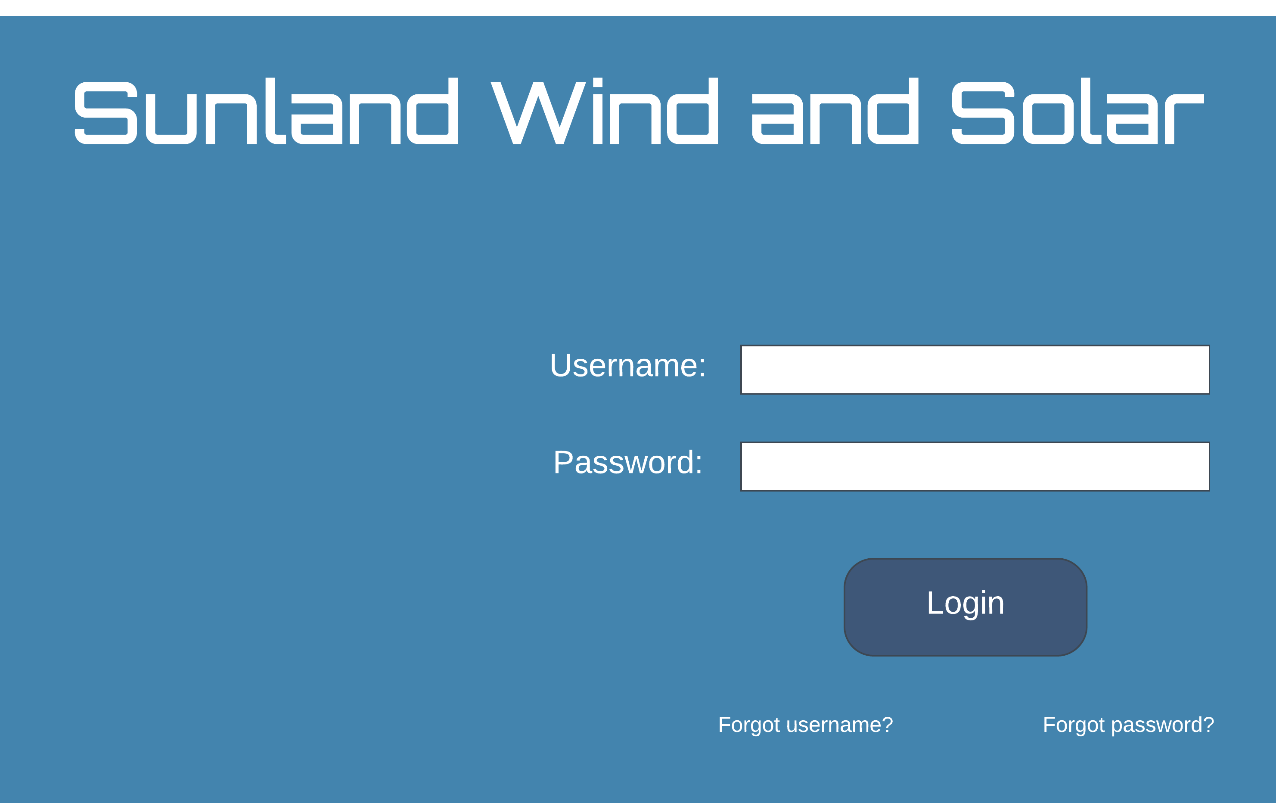

The organizational software uses a Google Calendar system for each installation employee. The website also uses the Google Calendar notification feature to alert the installer of new, updated, and removed installation times.

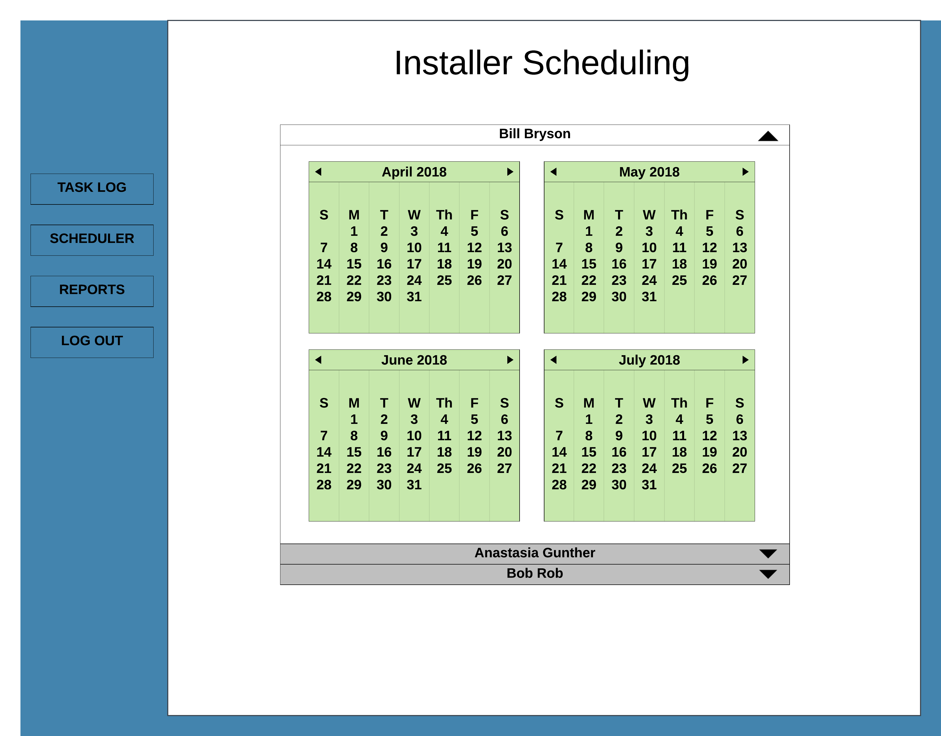

Another amazing feature our website system has is the ability to record, create, and update form automatically with the touch of a button. Want to get reports on salesmen to track their leads? Simply click on the salesperson’s name and create lead forms.

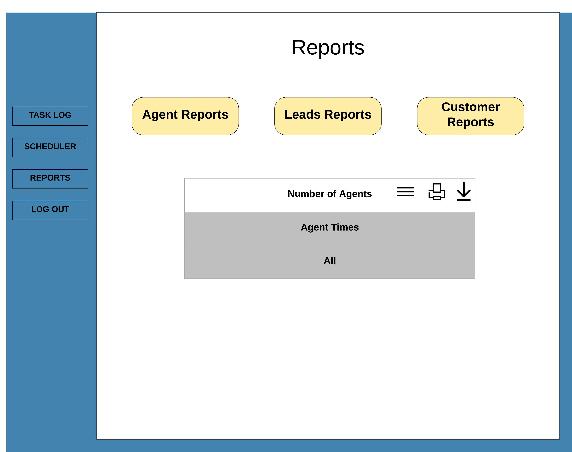

The website can access and manipulate the application’s information system to create, update, and delete leads as needed. This allows office personnel full access to the application while overlooking the information to ensure there are no conflicts. The task editor is an easy-to-use system that provides these features for the website.

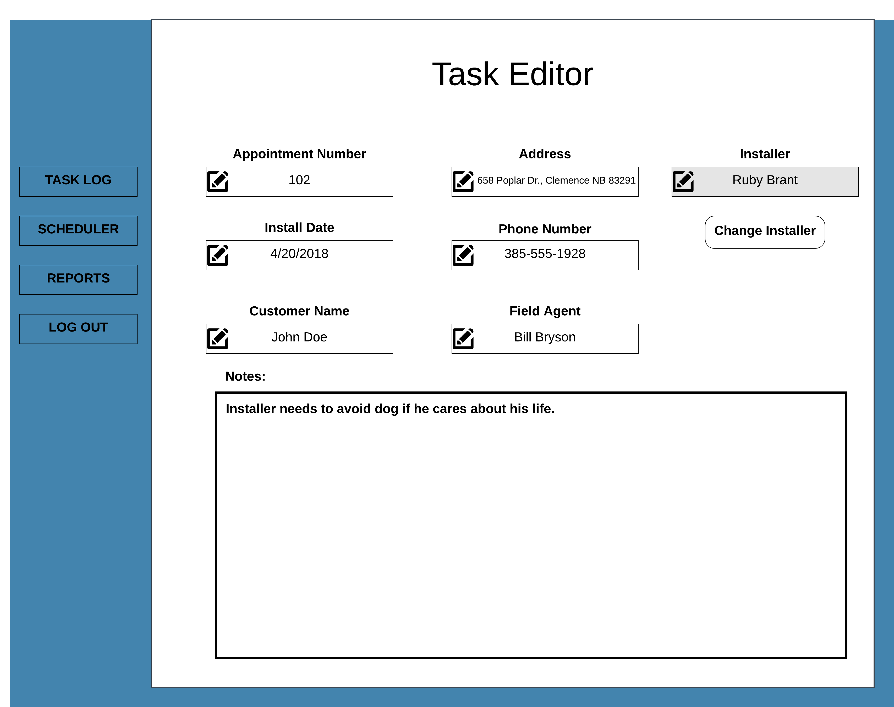

The website uses an overall logging system to organize all the tasks into one convenient place, the task log. This logging system allows one to see all the tasks that have happened and all that are going to happen between a day, week, and months’ time. This will be automatically updated when a new task is created, changed or deleted along with the date and time of action.

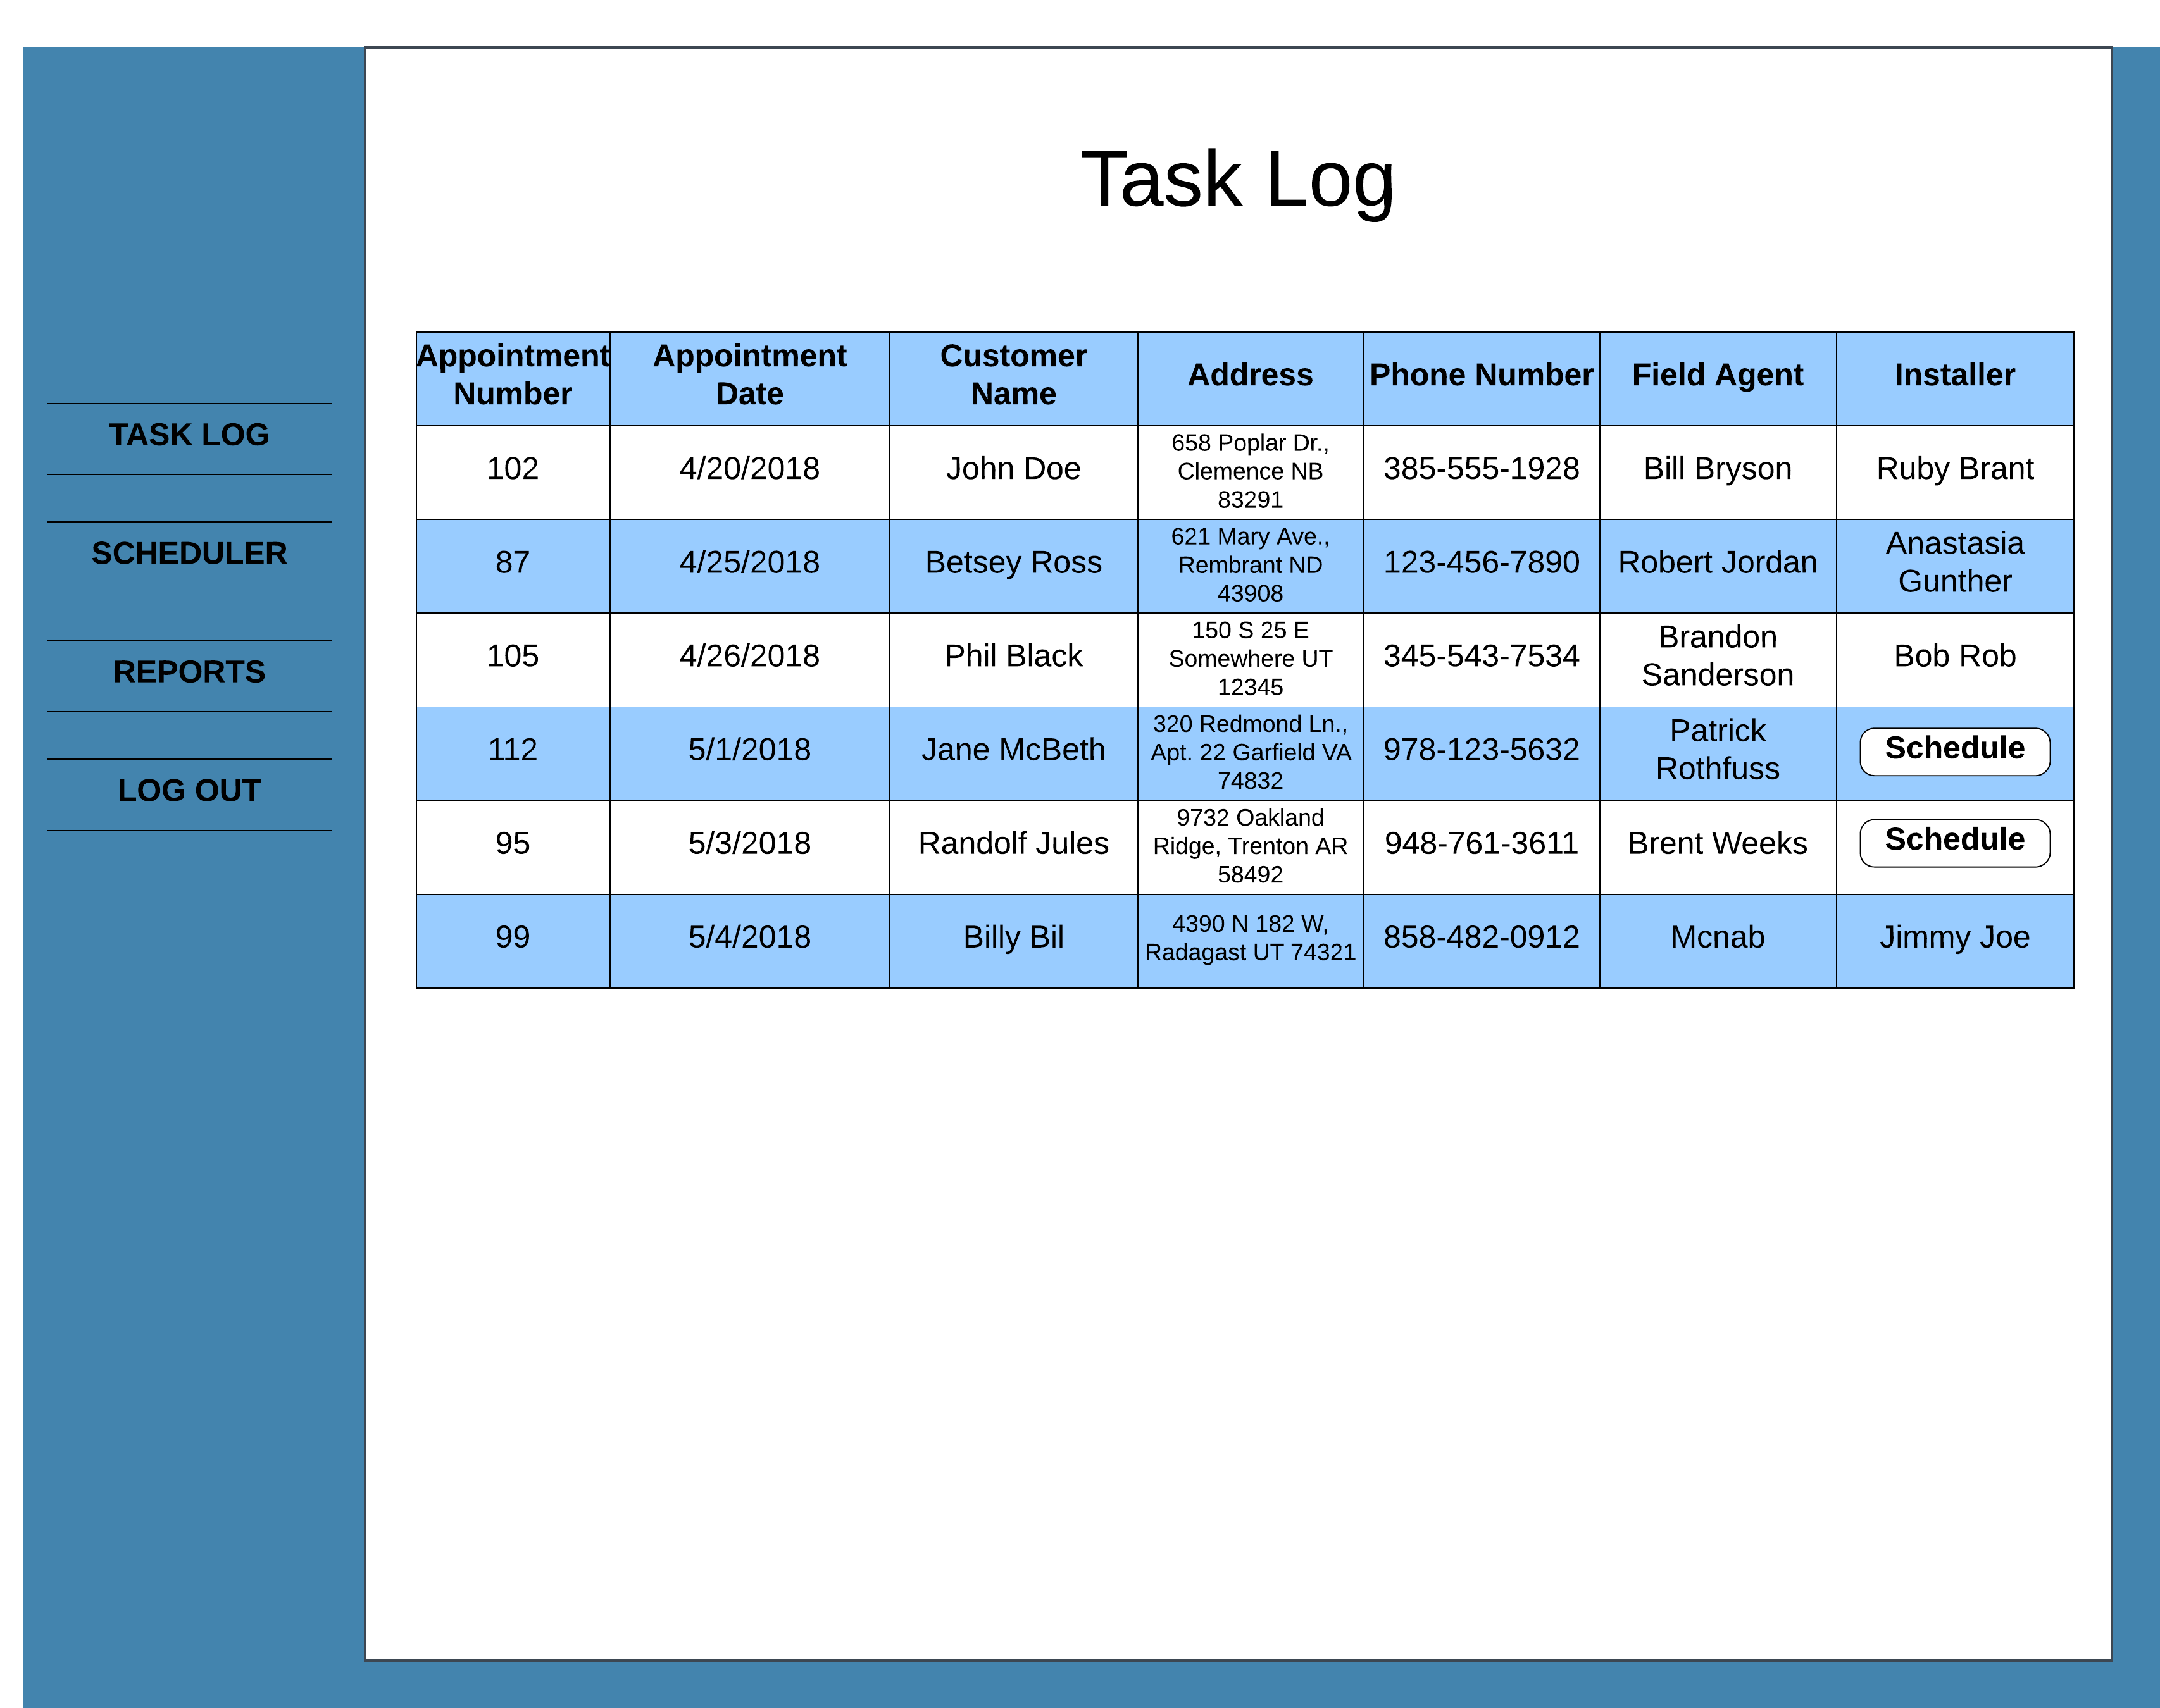

## Mobile Application User Interface

The mobile application has been designed and tailored to the specific needs of Sunland Wind & Solar company. With an interface that is pleasing to the eye, while also proving features that fit all your needs, Shuriken Development has done it again! The mobile application is available across all platforms including The App Store, Google Play Store, and The Windows Store. The application starts with a simple Login Screen like the website. Requiring a username and password, as well as the same recovery system if one cannot remember their username and/or password.

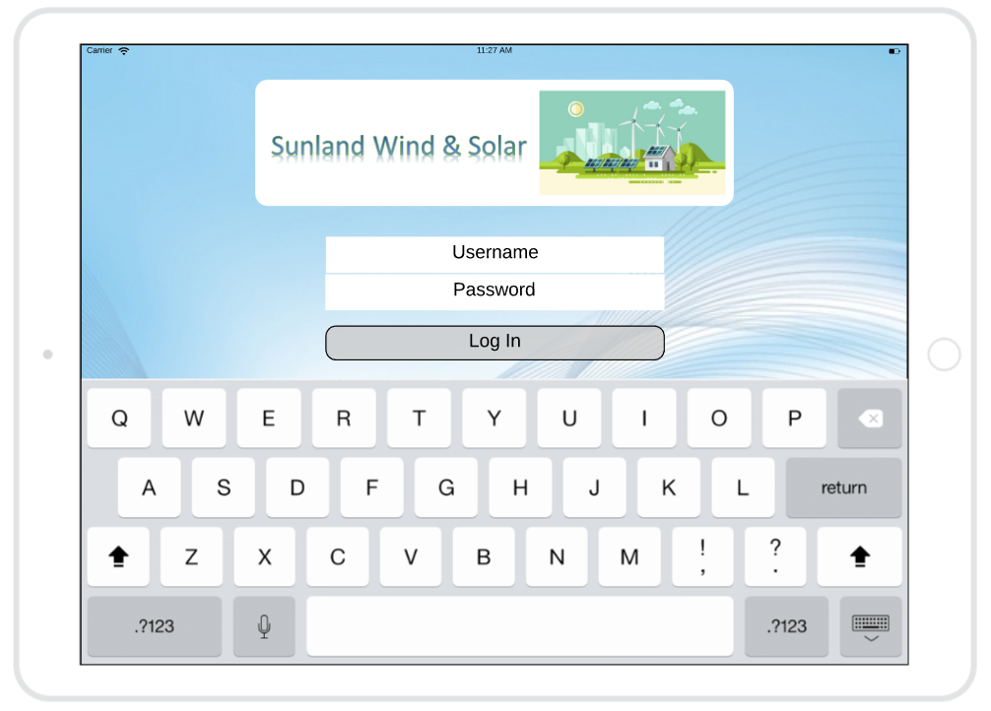

Once a user has logged into the system, they will then be presented with three options: clock in, check hours and payroll information, and the ability to log out as well.

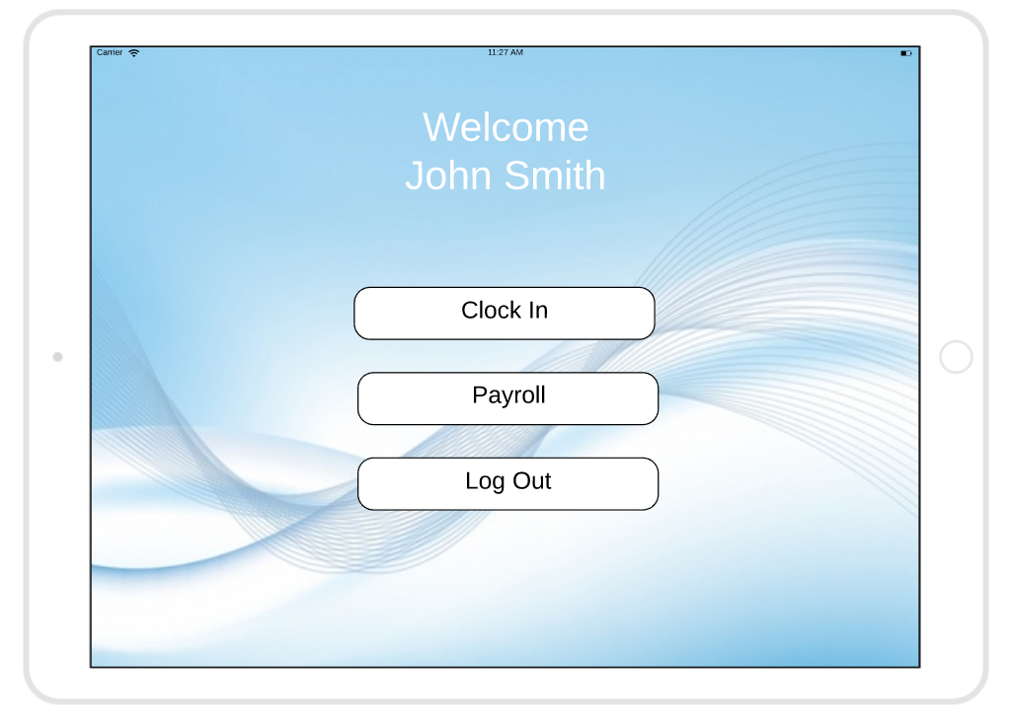

Upon clicking the “Clock In” option, the application will then bring up it’s integrated Google Maps server that will automatically bring the user to their assigned location for selling. As the salesmen go door-to-door they can click on the house and add a pin to that specific house where they have several different options. The first is the interested customer who has decided to request an install. Upon clicking “Request Install” a calendar will appear where it will show available install times. The salesmen can now request the install that works best for the customer and a notification will be sent to the install team of the requested time.

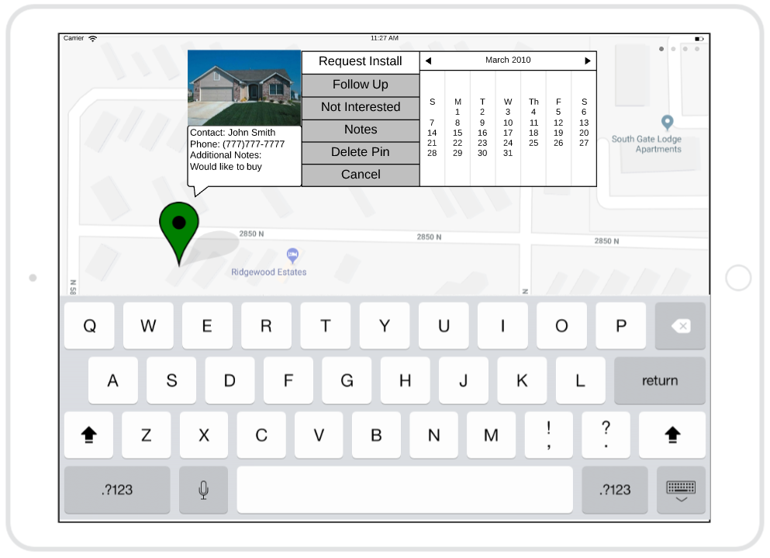

For the customer that might be interested or just doesn’t have the time for a sales pitch and has

asked you to come back later, there is a “Follow Up” option as well. This also lets you schedule a better meeting time for the customer with a convenient calendar next to the button. This will send you a notification when the follow up date is nearing closer.

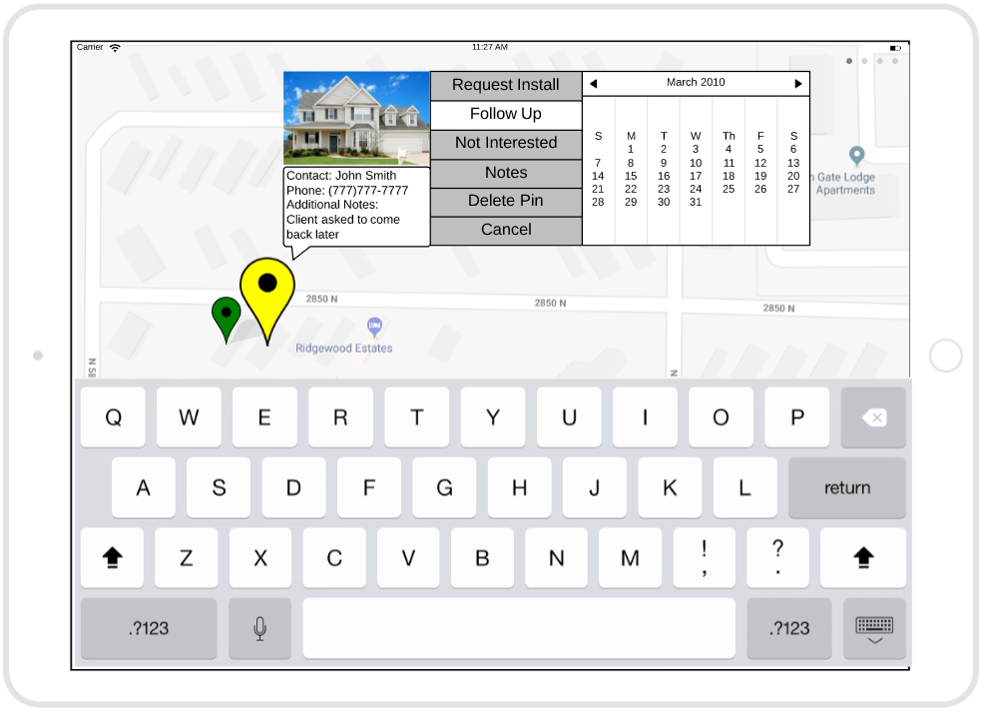

If a customer is simply not interested, or is a current customer, there is also an option to press the “Not Interested” button.

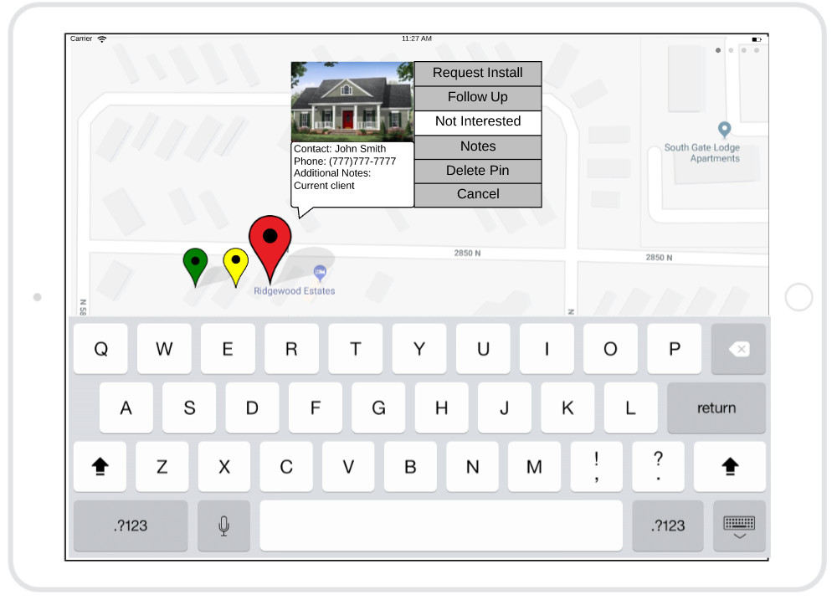

Each pin has the option to add, edit, and remove notes. Upon pressing the “Notes” button, a text box will appear where the calendar was and will show you all previous notes on the client. These notes are labeled with a name and date of when the notes were added to the system. The notes are shared across the company.

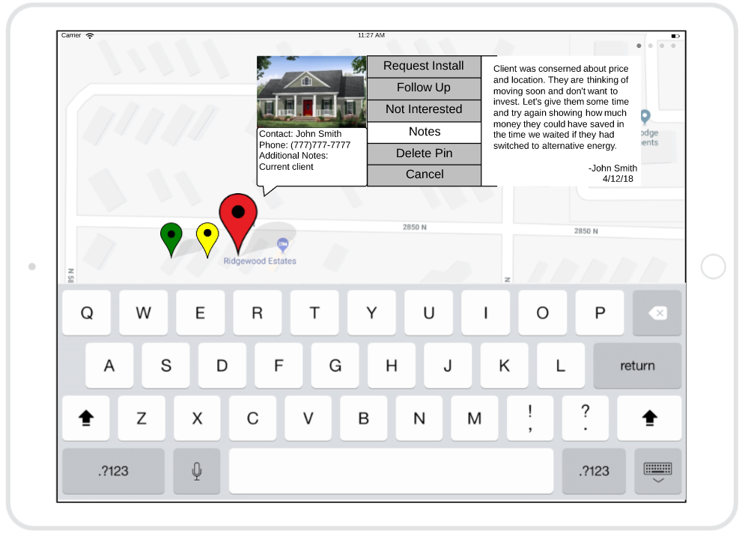

There is also an option to delete a pin. If you would like to delete a pin, an alert box will pop up asking you, “Are you sure?” ensure the confirmation of a deleted pin. The pin will be removed from the map, however, the notes associated with the pin will be kept on the cloud. This way one can look back and see all the notes that were the before for legal reason as well as convivence reasons.

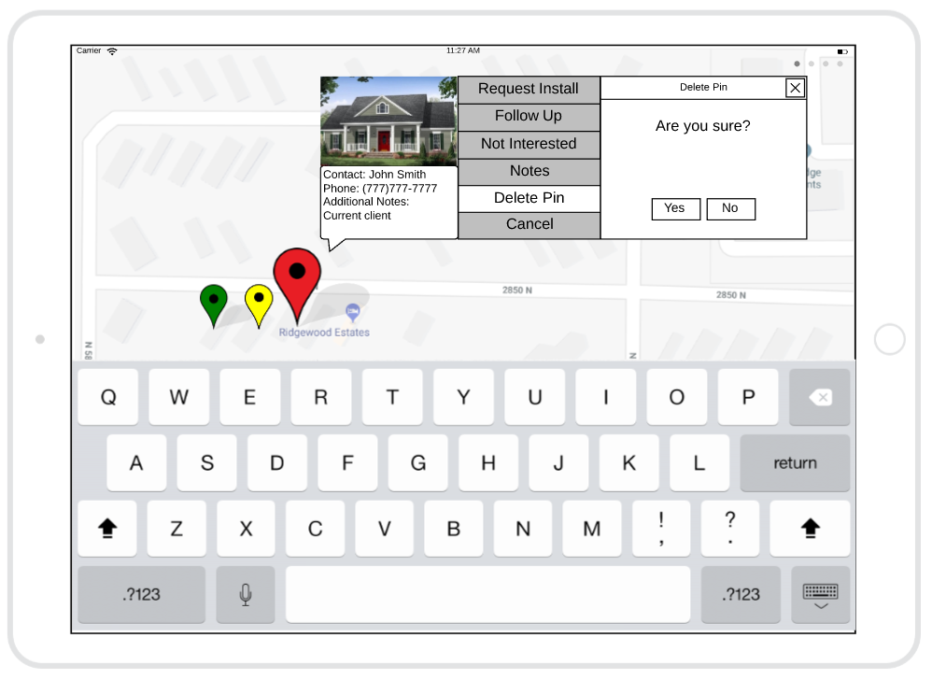

In the top right corner of the application, there are four dots that will open an option menu upon pressing. This will open a menu with multiple choices of buttons. The “Emergency” button will notify the company with the location and employee details that have pressed the button. Shuriken Development’s policy stats that you should rely on calling 911 before pressing the button. This feature allows the option to notify the company if there is a situation where calling 911 is not an option. There are also options to clock in from lunch and clock out for lunch. This helps keep payroll happy and provides more information on the employee’s location. Lastly, the “Clock Out” button and “Log Out” buttons are found in this options page as well.

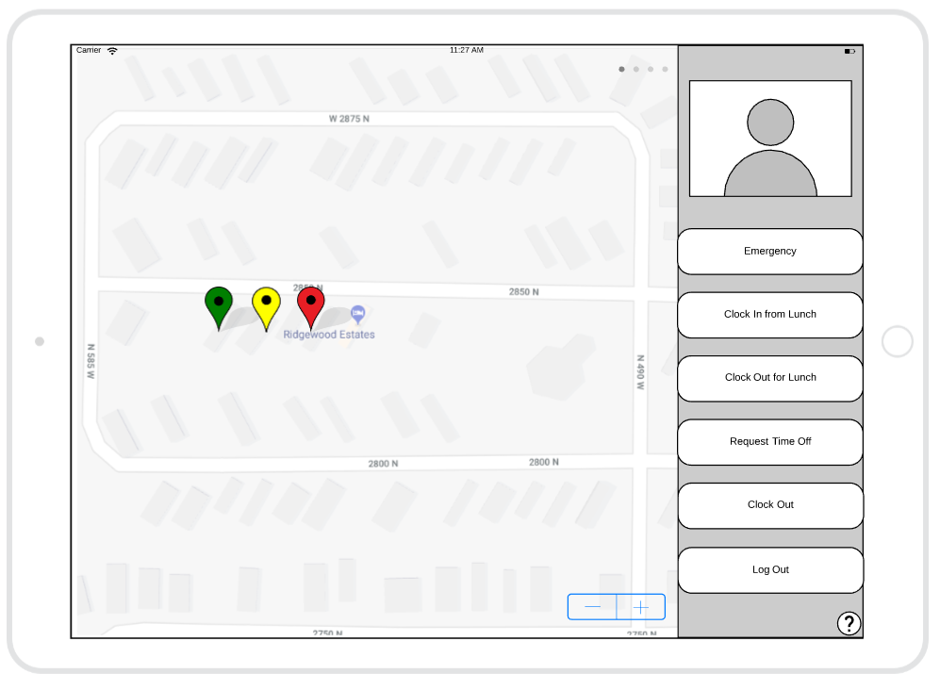

# Effort Breakdown Table

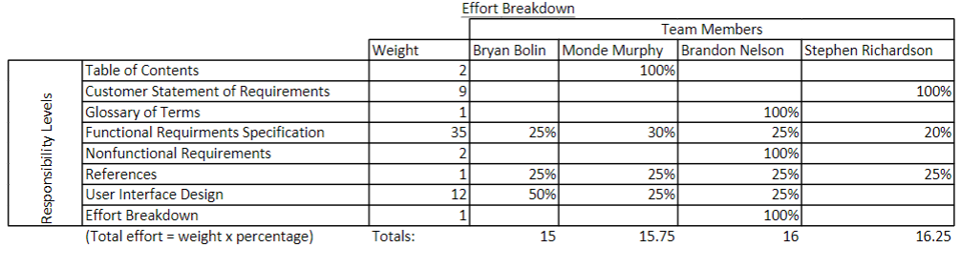

# Appendix